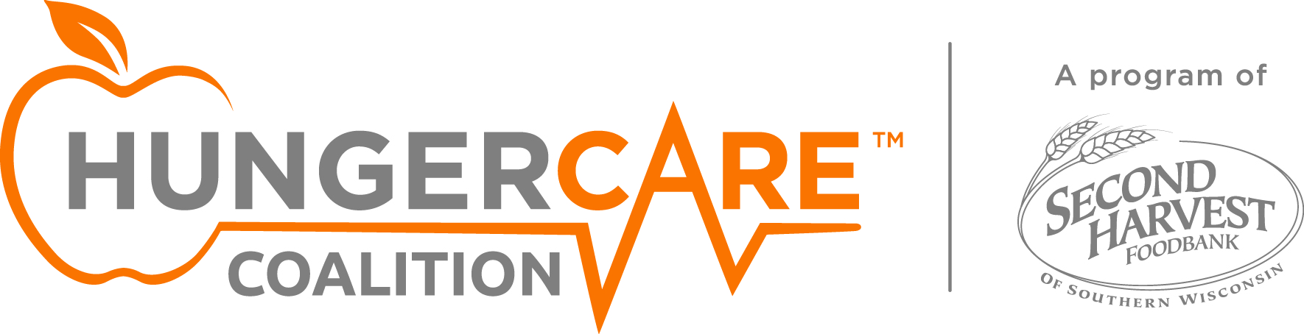

**2-1-1**

Get information on free meal sites and food pantries, finding housing, paying your bills, and more. Dial 2-1-1 to talk to an Information and Resource Specialist 24 hours a day or go to http://www.211wisconsin.org/.

**FoodShare Helpline (Quest Card)**

Get information, one-on-one help applying for money on a Quest card for groceries, and help with FoodShare renewals. Call 1-877-366-3635 or go to GetAQuestCard.org

**Women, Infants and Children (WIC)**

Get help getting healthy foods, nutrition education, and breastfeeding support for pregnant and postpartum women, infants, and children under age 5. Call the Maternal and Child Health Hotline at 1-800-722-2295 or go to https://www.dhs.wisconsin.gov/wic/wic-offices.htm to find the county WIC office in your area.

**Aging & Disability Resource Centers (ADRCs)**

Get services for seniors and adults with disabilities including nutrition, personal care, and financial assistance. Go to https://www.dhs.wisconsin.gov/adrc/consumer/index.htm or call 2-1-1 to find your county’s ADRC.

**Online Recipes and Tips for Healthy Eating on a Budget**

* USDA What’s Cooking Recipes- www.whatscooking.fns.usda.gov/
* Good & Cheap Cookbook - www.leannebrown.com
* Meeting Your MyPlate Goals On A Budget - http://tinyurl.com/healthyonabudget

https://www.choosemyplate.gov/budget

* MyPlate Tip Sheets - https://www.choosemyplate.gov/myplate-tip-sheets

**“I need more food.”**

Here are some resources that can help.